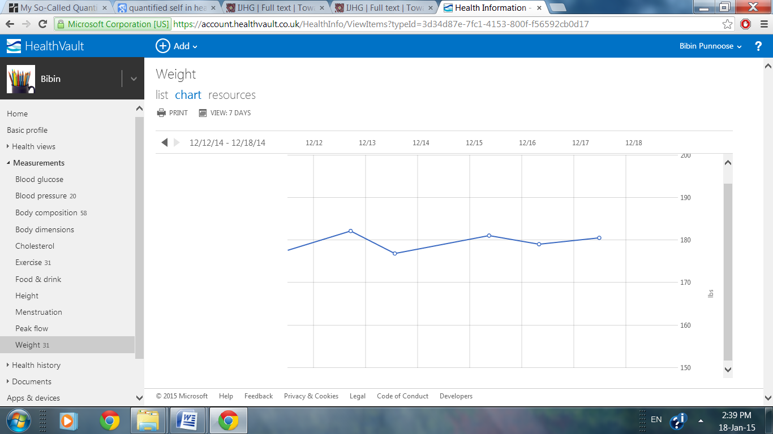
Fig. 3. Screenshot of weight trend in HealthVault

